Sorting Notes

# Merge Sort

<https://www.geeksforgeeks.org/merge-sort/>

* Divide-Sort-Merge

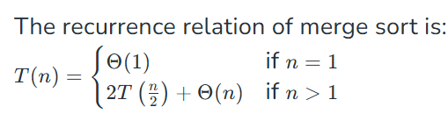

* Time Complexity:
  + **Best Case:** O(n log n), When the array is already sorted or nearly sorted.
  + **Average Case:** O(n log n), When the array is randomly ordered.
  + **Worst Case:** O(n log n), When the array is sorted in reverse order.
* Sorting large datasets
* sorting Linked lists.
* Stability
* Guaranteed O(N logN)
* Not in-place
* Slower than QuickSort in general

# Insertion Sort

<https://www.geeksforgeeks.org/insertion-sort-algorithm/>

* Move from left to right-compare current with all previous-find its correct place
* 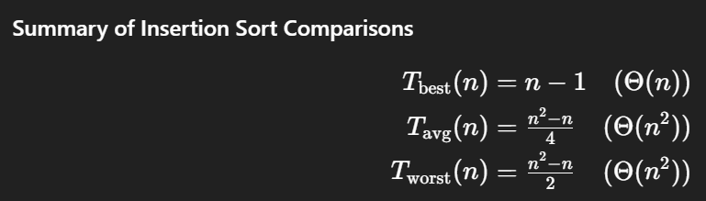
* Time Complexity
  + **Best case**: O(n), If the list is already sorted, where n is the number of elements in the list.
  + **Average case**: O(n2), If the list is randomly ordered
  + **Worst case:** O(n2), If the list is in reverse order
* Stable
* Efficient for small lists and nearly sorted lists (**main point**)
* in-place
* Used as a subroutine in Bucket Sort
* incremental approach.

# Quick Sort

<https://www.geeksforgeeks.org/quick-sort-algorithm/>

* Choose a Pivot-rearrange the Array left and right around pivot-repeat recursively
* 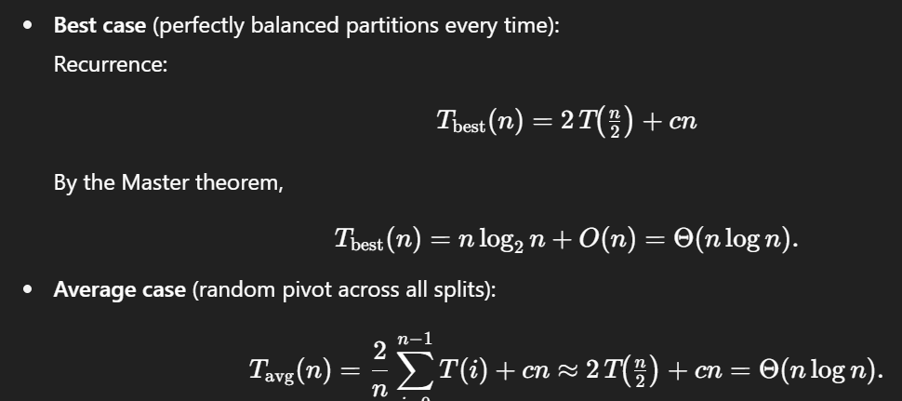 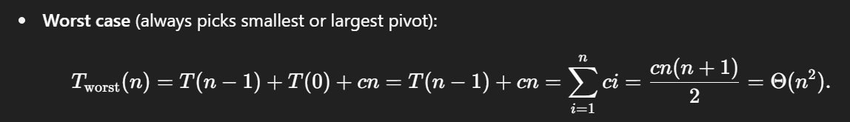
* Time Complexity:
  + **Best Case**: (Ω(n log n)), Occurs when the pivot element divides the array into two equal halves.
  + **Average Case**: (θ(n log n)), On average, the pivot divides the array into two parts, but not necessarily equal.
  + **Worst Case:** (O(n²)), Occurs when the smallest or largest element is always chosen as the pivot (e.g., sorted arrays).
* efficient on large data sets.
* low overhead
* Cache Friendly
* not stable
* in-place

# Heap Sort

<https://www.geeksforgeeks.org/heap-sort/>

* comparison-based
* buid a heap-swap root and last node-call heapify on new root
* 
* **Time Complexity:** O(n log n) in all cases
* in-place
* not stable
* 2-3 times slower than QuickSort
* Inefficient

# Counting Sort

<https://www.geeksforgeeks.org/counting-sort/>

* non-comparison-based
* count frequencies-count cumulative frequencies-place elements in output array using counts
* 
* Time Complexity: O(N+M), where N and M are the size of inputArray[] and countArray[] respectively.
  + **Worst-case:** O(N+k).
  + **Average-case:** O(N+k).
  + **Best-case:** O(N+k).
* Stable
* faster than all comparison-based
* stable
* doesn’t work on decimal
* not In-place sorting
* used as a subroutine in Radix Sort
* used in Bucket Sort

# Radix Sort

<https://www.geeksforgeeks.org/radix-sort/>

* linear sorting algorithm
* processing digit by digit
* sort the array by Least Significant digit in 1st iteration-then sort digit by digit until Most SD-use counting sort for individual digit sorting
* non-comparative
* 
* time complexity of O(d * (n + b)), where d is the number of digits, n is the number of elements, and b is the base of the number system being used
* faster for large datasets, especially when the keys have many digits
* not as efficient for small datasets.
* Stable
* Not in-place

# Bucket Sort

<https://www.geeksforgeeks.org/bucket-sort-2/>

* dividing elements into various groups, or buckets by uniformly distributing the elements
* Create buckets array-Take elements from input-multiply by bucket array size-apply floor-put this input element to this index of buckets array (use linked list for conflicted index)-concatenate buckets
* Sort elements in each bucket using stable algorithm (commonly used insertion sort because of small no of elements in a bucket)
* 
* Time Complexity
  + Worst Case: O(n2) hen one bucket gets all the elements
  + Best Case: O(n + k) when every bucket gets equal number of elements
* stable if the internal sorting algorithm used to sort it is also stable
* not in-place